Curriculum statement for the teaching of History at Helmdon Primary School
CURRICULUM DRIVERS
DIVERSITY | We teach a wide range of periods throughout history including civilisations from across the world. Pupils learn about the diverse ways people have lived in the past and their beliefs and practices. They are challenged to draw upon previous knowledge and undertake independent research. Through teaching the events in chronological order pupils are helped to make connections and find comparisons between the different time periods.
ORACY | Pupils are encouraged to use historical vocabulary to develop their knowledge of historical periods through discussion and debate. Through investigating questions, pupils talk through the reliability of historical accounts, understanding that there may be bias.
KEY CONCEPTS
In order to prepare pupils for their future learning in History, our history curriculum aims to introduce them to the following key substantive concepts in different contexts: | 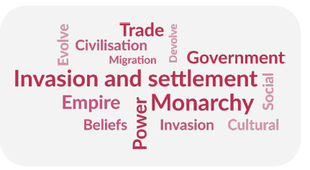  - Power  - Monarchy  - Invasion  - Settlement and migration  - Empire  - Civilisation  - Religion  - Trade  - Achievements of humankind  - Society and culture
Historical knowledge is shaped by disciplinary approaches. Over the course of the scheme, children develop their understanding of the following key disciplinary concepts: | 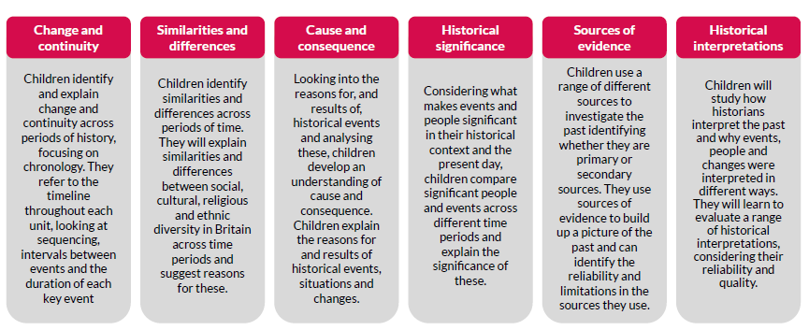  - Change and continuity  - Cause and consequence  - Similarities and differences  - Historical significance  - Historical interpretations  - Sources of evidence

INTENT
At Helmdon Primary School, history teaching promotes a curiosity and enthusiasm for learning about the past. Our pupils will explore the past, developing their understanding of why the past can be interpreted in different ways. They will enjoy learning about a range of periods through time, gaining an understanding of a variety of historical concepts and processes. Their resilience will increase as they are challenged about their own views and preconceptions through appropriate and accurate historical enquiry. Our pupils will learn the skills to understand the complexity of people’s lives and identify themes and patterns through history.

Our history curriculum aims to inspire pupils to be curious and creative thinkers who develop a complex knowledge of local and national history and the history of the wider world. We want pupils to develop the confidence to think critically, ask questions, and be able to explain and analyse historical evidence. Through our chosen scheme of work, we aim to build an awareness of significant events and individuals in global, British and local history and recognise how things have changed over time. History will support children to appreciate the complexity of people’s lives, the diversity of societies and the relationships between different groups. Studying History allows children to appreciate the many reasons why people may behave in the way they do, supporting children to develop empathy for others while providing an opportunity to learn from mankind’s past mistakes. Our curriculum aims to support pupils in building their understanding of chronology, making connections over periods of time and developing a chronologically-secure knowledge of History. We hope to develop pupils’ understanding of how historians study the past and construct accounts and the skills to carry out their own historical enquiries. In order to prepare pupils for their future learning in History, our scheme aims to introduce them to key substantive concepts. Kapow Primary’s History scheme of work is aligned to the National Curriculum and enables pupils to meet the end of Key Stage attainment targets in the National Curriculum.

UNDERPINNED BY:
VOCABULARY | CHRONOLOGICAL UNDERSTANDING | QUESTIONING | KNOWLEDGE
Our pupils will understand and use ambitious historical vocabulary to further develop their understanding of the substantive concepts. | Our pupils will understand chronology and identify patterns and themes in history.  Each unit has a focus on chronology to allow children to explore the place in time of the period they are studying and make comparisons in other parts of the world. Children will develop their awareness of the past in Key stage 1 and will know where people and events fit chronologically. This will support children in building a ‘mental timeline’ they can refer to throughout their learning in  Key stage 2 and identifying connections, contrasts and trends over time. | Our pupils will learn to question sources from history, developing their enquiry skills.  Units are organised around an enquiry-based question and children are encouraged to follow the enquiry cycle (Question, Investigate, Interpret, Evaluate and conclude,  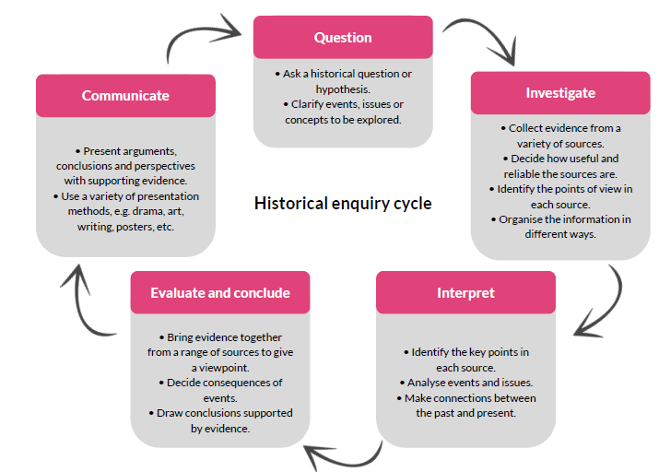  Communicate) when answering historical questions. | Our pupils will develop their knowledge of a range of periods throughout history, making purposeful links between them.  Our chosen scheme follows the spiral curriculum model where previous skills and knowledge are returned to and built upon: children progress by developing their knowledge and understanding of substantive and disciplinary concepts by experiencing and revisiting them in a range of historical contexts and periods.  ‘Knowledge of the past must be shaped by disciplinary approaches in order to become historical knowledge.’ (Ofsted research review series: History, 2021)  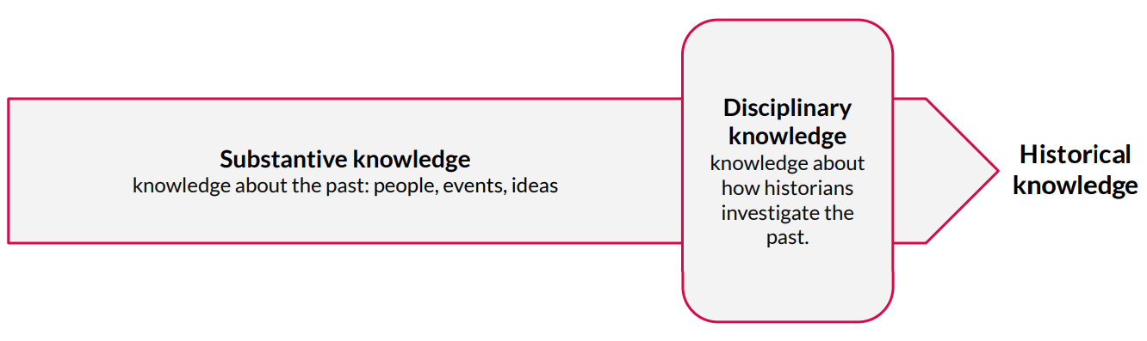

IMPLEMENTATION
High Quality Teaching | Carefully planned lessons will engage pupils and provide them with the opportunity to develop their understanding of periods throughout time. In each topic, our pupils learn historical vocabulary and terminology and also reinforce previously earlier in a broader range of contexts. Integrated CPD means
Questioning | Insightful questioning that encourages deeper thinking and the consideration of other viewpoints.
Discussion | Open discussions give opportunities for pupils to share and consolidate their knowledge. Our pupils can talk about similarities and differences between periods of history.
Local links | Where possible, local links will be made to the history of the local community to develop the pupils’ sense of perspective.
Enrichment | Pupils will be given the opportunity to develop their skills and knowledge beyond the classroom. This will include off-site visits and visitors.
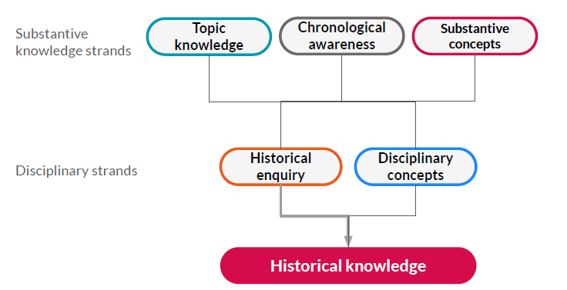
The Kapow Primary scheme emphasises the importance of historical knowledge being shaped by disciplinary approaches, as shown in the diagram. These strands are interwoven through all our History units to create engaging and enriching learning experiences which allow the children to investigate history as historians do. Each six-lesson unit has a focus on chronology to allow children to explore the place in time of the period they are studying and make comparisons in other parts of the world. Children will develop their awareness of the past in Key stage 1 and will know where people and events fit chronologically. This will support children in building a ‘mental timeline’ they can refer to throughout their learning in Key stage 2 and identifying connections, contrasts and trends over time. The Kapow Primary timeline supports children in developing this chronological awareness. Children are encouraged to follow the enquiry cycle (Question, Investigate, Interpret, Evaluate and conclude, Communicate) when answering historical questions.
Over the course of the scheme, children develop their understanding of the following key disciplinary concepts:
• Change and continuity.
• Cause and consequence.
• Similarities and differences.
• Historical significance.
• Historical interpretations.
• Sources of evidence.
These concepts will be encountered in different contexts during the study of local, British and world history. Accordingly, children will have varied opportunities to learn how historians use these skills to analyse the past and make judgements. They will confidently develop and use their own historical skill set.

Substantive concepts such as power, trade, invasion and settlement, are introduced in Key Stage 1, clearly identified in Lower Key Stage 2 and revisited in Upper Key Stage 2 (see Progression of skills and knowledge) allowing knowledge of these key concepts to grow. These concepts are returned to in different contexts, meaning that pupils begin to develop an understanding of these abstract themes which are crucial to their future learning in History.

History in Action videos explain the careers and work of those in history and heritage-related fields. Historians, archivists, archaeologists, museum curators, teachers and heritage experts discuss their love of history, how they became interested in the subject, how they got into their jobs and what their jobs involve.

Lessons are designed to be varied, engaging and hands-on, allowing children to experience the different aspects of an historical enquiry. In each lesson, children will participate in activities involving disciplinary and substantive concepts, developing their knowledge and understanding of Britain’s role in the past and that of the wider world. Children will develop their knowledge of concepts and chronology as well as their in-depth knowledge of the context being studied.

Differentiated guidance is available for every lesson to ensure that lessons can be accessed by all pupils and opportunities to stretch pupils’ learning are available when required. Knowledge organisers for each unit support pupils in building a foundation of factual knowledge by encouraging recall of key facts, concepts and vocabulary.

Strong subject knowledge is vital for staff to be able to deliver a highly-effective and robust history curriculum and the integrated CPD allows them to do just that. Each unit of lessons focuses on the key subject knowledge needed to deliver the curriculum, making links with prior learning and identifying possible misconceptions. Kapow has been created with the understanding that many teachers do not feel confident delivering the History curriculum and every effort has been made to ensure that they feel supported to deliver lessons of a high standard.

IMPACT
Children will:
- Know and understand the history of Britain, how people’s lives have shaped this nation and how Britain has influenced and been influenced by the wider world.
- Develop an understanding of the history of the wider world, including ancient civilisations, empires, non-European societies and the achievements of mankind.
- Develop a historically-grounded understanding of substantive concepts - power, invasion, settlement and migration, civilisation, religion, trade, achievements of mankind and society.
- Use newly acquired vocabulary to interpret and convey their understanding of the past
- Be increasingly aware of how historical events have shaped the world that they currently live in
- Be able to retain prior-learning and explicitly make connections between what they have previously learned and what they are currently learning
- Form historical arguments based on cause and effect, consequence, continuity and change, similarity and differences.
- Have an appreciation for significant individuals, inventions and events that impact our world both in history and from the present day.
- Understand how historians learn about the past and construct accounts.
- Ask historically-valid questions through an enquiry-based approach to learning to create structured accounts.
- Explain how and why interpretations of the past have been constructed using evidence.
- Make connections between historical concepts and timescales.
- Meet the end of key stage expectations outlined in the National curriculum for History

Assessment in History
Formative assessment
Each lesson contains the ‘Assessing progress and understanding’ section which helps teachers to identify those pupils who are secure in their learning.
Summative assessment
The disciplinary strands are assessed using a Skills catcher at the end of each unit. This requires children to draw upon their disciplinary knowledge in order to respond to an outcome task. Each disciplinary concept is assessed at least once by the end of Key stage 1 and once by the end of Key stage 2 using historical enquiry skills. Skills catchers provide teachers with a record of summative assessment as evidence of progression from Key stage 1 to Key stage 2.
Substantive concepts will be assessed using an end of unit quiz in Key stage 2.

